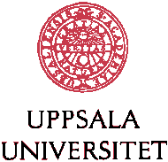

Education for Equity ~ looking back and moving forward

Welcome to a webinar!

Thursday 29th April 2021, 14:00-17:00 CET in Zoom

Programme (preliminary)

14:00 – 14:15 Welcome & introduction
14:15 – 14:30 A Provocation - A think piece from Professor Victor Merriman, Edge Hill University, UK
14:30 – 14:50 One size doesn’t fit all - Presentation by members of AVCT, Liverpool, UK
14:50 – 15:10 Break

15:10 – 15:30 Integration of refugees into the vocational training system: Connect + - Presentation by Uwe Schulte, Khalid Sharif, BWK, Berlin, Germany
15:30 – 15:50 Multilingual Learning, UF – Young Enterprise Learning
- Presentation by Ingrid Jonsson, Celsiusskolan, Uppsala, Sweden

15:50 – 16:40 Table talks/ Group discussions (including short break)

16:40 – 17:00 Summing up & closing remarks

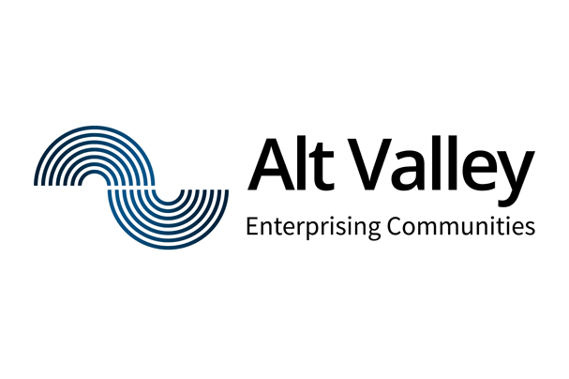 | 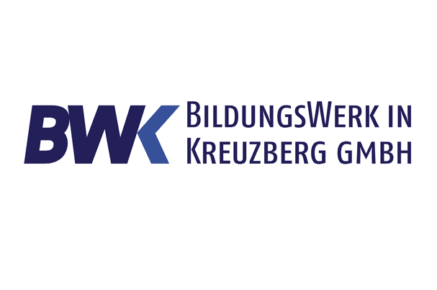 |  | 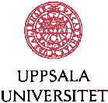 | 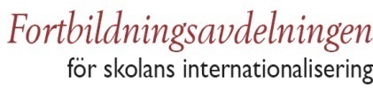

Presentations:

Victor Merriman – A Provocation
Victor Merriman is Professor of Critical Studies in Drama at Edge Hill University. He is author of "Because We Are Poor": Irish Theatre in the 1990s (2011) and Austerity and the Public Role of Drama: Performing Lives-in-Common (2019). He is a founder director of One Hour Theatre Company.

AVCT – One size doesn’t fit all
In response to the current challenges Alt Valley Community Trust have established a Youth Hub to support 16-24 year olds who are not in full time education or employment. The key to this successful initiative is the focus upon meeting the needs of every individual in order to secure long-term successful futures.
Presentation by members of AVCT, Liverpool, UK

BWK – The integration of refugees into the vocational training system: Connect +
The aim of our project is to provide support for young refugees to connect to the German dual vocational training system, once they finish previous schools.
The refugees, when they finish school, need an individual career coaching, which can strengthen their individual professional development. At our college they can acquire work experience in different professional fields, and at the same time receive specific work related language training.
Presentation by Uwe Schulte and Khalid Sharif, BWK, Berlin, Germany
Celsiusskolan – Multilingual Learning and UF – Young Enterprise Learning
To strengthen the students’ deeper knowledge, we encourage multilingual learning. A topic and instructions are given in Swedish, then analyzed and discussed in their first language(s) and then put forward in Swedish. Furthermore, to develop students’ financial future possibilities they learn to start and run a real company of choice, supervised by teachers and encouraged by different competitions for young enterprises.
Presentation by Ingrid Jonsson, Assistant Principal for newly arrived students to Sweden of 16-20 years at Celsiusskolan, Uppsala, Sweden

